

Tech Saksham

Case Study Report

Data Analytics with Power BI

**“Supply Chain Analysis of Inventories”**

**“Sacred Heart College of Arts and science –Dindigul-03”**

|  |  |
| --- | --- |
| **NM ID** | **NAME** |
| 00BF2AD46827B7CA4DF473E08C7B0504 | **ROSAN G.B**  **C1S30807** |

Trainer Name: R. UMAMAHESWARI Master Name: R. UMAMAHESWARI

**ABSTRACT**

The implementation of PowerBI in "Analytics Supply Chain" has effectively showcased the potential of data analytics within the industry. Through the analysis of customer data in the supply chain, valuable insights on customers, products, sales, discounts, and total revenue have been uncovered. The utilization of interactive dashboards and reports has provided a comprehensive overview of customer data, facilitating the detection of patterns and correlations. This advancement not only enhances the efficiency of data analysis but also elevates the capacity of the products to offer personalized services, identify opportunities for cross-selling and up-selling, and tailor products and services to align with customer preferences. Furthermore, this project is poised to contribute to the broader objective of digital transformation within the banking sector, fostering efficiency, innovation, and customer-centricity.



# INDEX

|  |  |  |
| --- | --- | --- |
| **Sr. No.** | **Table of Contents** | **Page No.** |
| 1 | Chapter 1: Introduction | 1 |
| 2 | Chapter 2: Services and Tools Required | 4 |
| 3 | Chapter 3: Project Architecture | 5 |
| 4 | Chapter 4: Modeling and Result | 9 |
| 5 | Conclusion | 12 |
| 6 | Future Scope | 13 |
| 7 | References | 14 |
| 8 | Links | 15 |

**CHAPTER 1 INTRODUCTION**

## Problem Statement

Nowadays, Inventory analysis is vital to supply chain optimization since it can help consolidate suppliers or shift to single sourcing (to reduce overhead and simplify the operation). Supply chain management is a process of managing supply relationships outside a company and the flow of stock into and through a company. Inventory management may focus on trends and orders for the company or a part of the company. Inventory management is essential for a properly running supply chain. Today, many inventory management systems use AI to analyze trends in your logistics, raw materials, and warehousing operations in real time so supply chain managers can make fast adjustments to keep the flow of goods moving. Big data allows us to see the future,

using to spot trends early.

predictive analytics

## Proposed Solution

The proposed solution is to develop a PowerBI dashboard that can analyze and visualize real- time customer data. Supply chain inventory planning involves forecasting demand and deciding exactly how much inventory is needed and when to order it. It helps companies meet demand while reducing expenses. By having just the right amount of inventory in the right place at the right time, you can reduce the overall cost of storing products, optimize inventory allocation routes, and ensure that there is always the right amount of stock to meet customer demand. It will provide a comprehensive view of customer behavior, preferences, and trends, enabling banks to make informed decisions. The real-time analysis capability of the dashboard will enable banks to respond promptly to changes in customer behavior or preferences, identify opportunities for cross-selling and up-selling, and tailor their products and services to meet customer needs.

## Feature

* **Real-Time Analysis**: The dashboard will provide real-time analysis of customer data.
* **Customer Segmentation**: It will segment customers based on various parameters like age, income, transaction behavior, etc.
* **Trend Analysis**: The dashboard will identify and display trends in customer behavior.
* **Predictive Analysis**: It will use historical data to predict future customer behavior.

## Advantages

* + 1. **Lower costs:** Supply chains allow businesses to take advantage of lower costs associated with foreign markets. Companies can source materials from countries with cheaper labour and production costs, resulting in more cost-efficient operations.
    2. **Increased flexibility:** Supply chains provide companies with the flexibility to quickly adjust their operations to meet customer demand. This allows businesses to respond quickly to changes in the market, such as new product releases or a shift in consumer preferences.
    3. **Improved quality:** By leveraging the latest technology and data analytics, global supply chains can ensure higher levels of quality control. This can result in improved customer satisfaction and loyalty.
    4. **Greater efficiency:** Supply chains are designed to be efficient and streamlined. By optimizing processes and leveraging technology, businesses can reduce waste and increase productivity.
    5. **Increased market reach:** Supply chains allow businesses to expand their reach into new markets and tap into new sources of revenue.

## Scope

The scope of inventory management concerns the fine lines between replenishment lead time, carrying costs of inventory, asset management, inventory forecasting, inventory valuation, inventory visibility, future inventory price forecasting, physical inventory, available physical space, quality management, replenishment. The project can be further extended to incorporate more data sources and advanced analytics techniques, such as machine learning and artificial intelligence, to provide more sophisticated insights into customer behavior. The project also has the potential to be adapted for other sectors, such as retail, healthcare, and telecommunications, where understanding customer behavior is crucial. Furthermore, the project contributes to the broader goal of digital transformation in the banking sector, promoting efficiency, innovation, and customer-centricity.

# CHAPTER 2

**SERVICES AND TOOLS REQUIRED**

## Services Used

* + - **Data Collection and Storage Services**: One crucial step for any company is to collect and analyzes data to manage and mitigate risk and ensure smooth operations. The process starts by gathering data from diverse sources within the supply chain. This encompasses information from suppliers, production facilities, distribution centers, transportation systems, sales records, customer feedback and external market data, such as weather forecasts and social media APIs.

## Tools and Software used

### Tools:

* + - **PowerBI**: The main tool for this project is PowerBI, which will be used to create interactive dashboards for supply chain analysis visualization.
    - **Power Query**: This is a data connection technology that enables you to discover, connect, combine, and refine data across a wide variety of sources.

### Software Requirements:

* + - **PowerBI Desktop**: This is a Windows application that you can use to create reports and publish them to PowerBI.
    - **PowerBI Service**: This is an online SaaS (Software as a Service) service that you use to publish reports, create new dashboards, and share insights.
    - **PowerBI Mobile**: This is a mobile application that you can use to access your reports and dashboards on the go.

# CHAPTER 3 PROJECT ARCHITECTURE

## Architecture

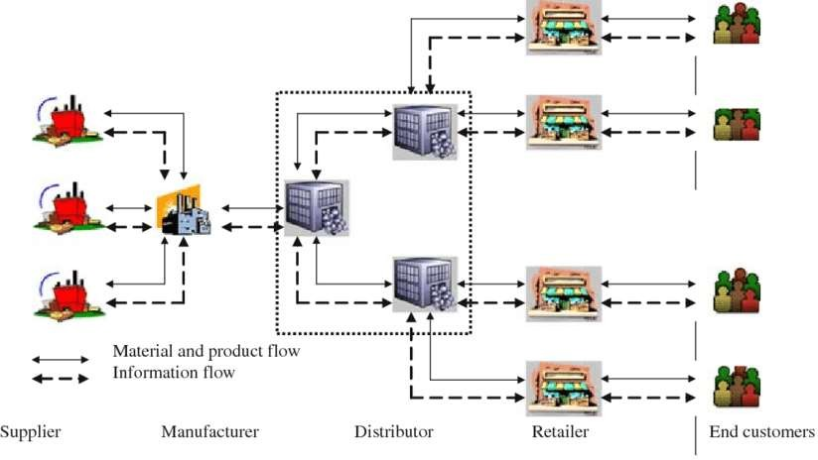

Here’s a high-level architecture for the project:

* + - **Data Collection**: This encompasses information from suppliers, production facilities, distribution centers, transportation systems, sales records, customer feedback and external market data, such as weather forecasts and social media APIs.
    - **Data Storage**: The collected data is stored in a database for processing. Storage plays a vital part in the supply chain given that it helps to guarantee good delivery times and reduce warehouse losses, making it possible to offer better services, to occupy a position ahead of competitors and, ultimately, to increase profits.
    - **Data Processing**: Inventory management, a critical element of the supply chain, is tracking inventory from manufacturers to warehouses and from these facilities to the point of sale. Inventory management aims to have the right products in the right place at the right time.
    - **Data Visualization**: The processed data and the results from the predictive models are visualized in supply chain analysis using PowerBI. PowerBI allows you to create interactive dashboards that can provide valuable insights into the data.
    - **Data Access**: The dashboards created in PowerBI can be accessed through PowerBI Desktop, PowerBI Service (online), and PowerBI Mobile.

This architecture provides a comprehensive solution for real-time analysis Inventory analysis is vital to supply chain optimization since it can help you consolidate suppliers or shift to single sourcing (to reduce overhead and simplify your operations). The function of inventory in logistics and SCM is to serve as a buffer between production and consumption, ensuring smooth operations. In logistics and SCM, it helps to manage uncertainties, facilitate production processes, and meet fluctuating customer demands. This efficiency can be reflected in every aspect of the chain, from idea creation to the final product marketing.

## Inventory Process Flow

In any business, be it retail, manufacturing, or other, a typical inventory process flow includes these stages:

### Purchasing

Companies buy inventory based on either their estimate of what’s needed or, in the best-case scenario, on preliminary inventory planning research. Although excess inventory is generally undesirable, businesses may overstock when making their first purchases.

### Storage

Companies must store inventory in a clean, secure area. They will incur holding costs to cover lighting and heating or refrigeration.

### Usage

Organizations take stock items from inventory for their intended purpose as sales items, raw materials, or repair parts.

### Tracking

Tracking stock as organizations retrieve or consume is essential to maintaining production flow, cash flow, and satisfied customers. Only by tracking what’s in stock can you know what and when to reorder.

### Reordering

You can reorder or replenish inventory automatically or manually. Mathematical, management, and strategy models help you understand the optimal stock level to maintain, as well as the number of items to order and how often to order them.

### Forecasting

Established enterprises and newer organizations that have experienced a few inventory cycles can anticipate, or forecast, inventory needs and timing. Forecasting helps to ensure you maintain optimal stock levels throughout the year.

# CHAPTER 4 MODELING AND RESULT

**Manage relationship**

The “disp” file will be used as the main connector as it contains most key identifier (account id, client id and disp id) which can be use to relates the 8 data files together. The “district” file is use to link the client profile geographically with “district id”

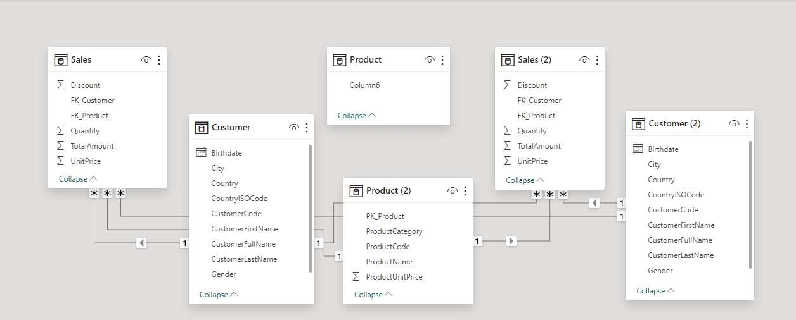

### Modelling for Gender and Age data

Notice that the Gender and age of the client are missing from the data.

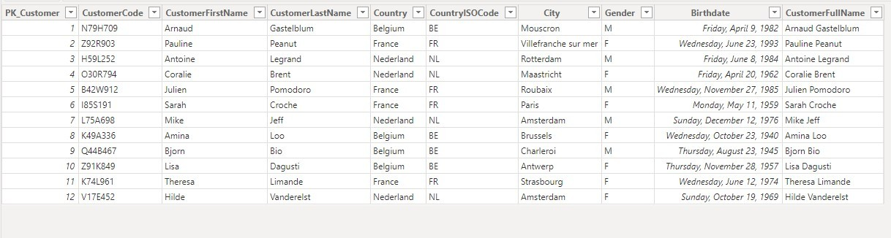

Values of such as Costumers code, Costumer First Name, Costumer Last Name, Country, Country ISO code, City, Gender, Birth date, Costumer Full Name have also been set as Text. Data Analytics with PowerBI.

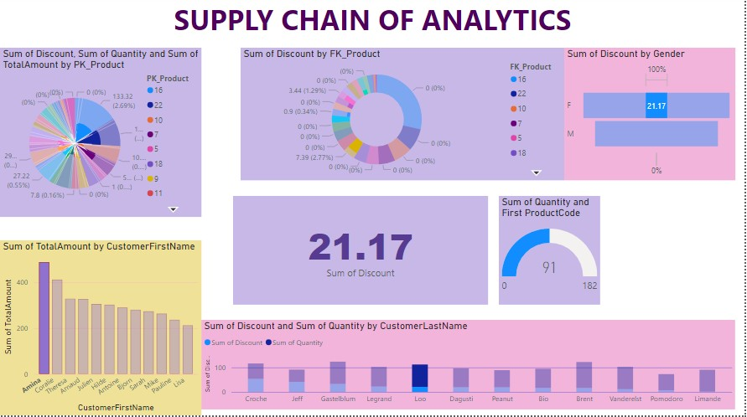**Dashboard**

# CONCLUSION

The utilization of PowerBI in the "Supply Chain of Analytics" project has effectively showcased the prowess of data analytics within the sector. By analyzing customer data along the supply chain, valuable insights into customers, products, sales, discounts, and total revenue have been garnered. Through interactive dashboards and reports, a holistic perspective of customer data has been provided, facilitating the identification of patterns and correlations. This advancement not only bolsters the efficiency of data analysis but also amplifies the product's capacity to deliver personalized services to its clientele. Furthermore, the project underscores the significance of data visualization in rendering complex data more comprehensible and accessible. Leveraging PowerBI has enabled the presentation of data in visually engaging and user-friendly formats, thereby aiding in enhanced product selling strategies

# FUTURE SCOPE

The future potential of this project is extensive. With the advancement of advanced analytics and machine learning, PowerBI stands poised to forecast future trends based on historical data. By incorporating predictive analytics, the bank could foresee customer needs and offer proactive solutions. Moreover, PowerBI's capacity to integrate with diverse data sources opens avenues for incorporating varied datasets, leading to a more comprehensive understanding of customers.

As data privacy and security grow in importance, future iterations of this project should prioritize robust data governance strategies. This ensures the secure management of sensitive customer data while adhering to data protection regulations. Additionally, exploring the integration of real-time data streams could provide even more timely and pertinent insights. This potential transformation in how banks engage with customers could result in heightened customer satisfaction and loyalty

# REFERENCES

https://supplychainmanagement.utk.edu/blog/inventory-management-in-supply- chain/

# LINK

<https://github.com/>